Discussion Assignment 4
Part 1
Graphing both a function and its inverse on the same set of axes with the x-axis representing the input highlights the symmetric relationship between the two functions. It shows how they are reflections of each other across the line y = x and how they swap roles in terms of their domains and ranges. For instance, $f(x)=x^{2}$ and $f^{-1}\left(x\right)=x^{1/2}$ are both a function and its inverse respectively. The graphical representation below can help in understanding the concept of inverse functions and their properties.
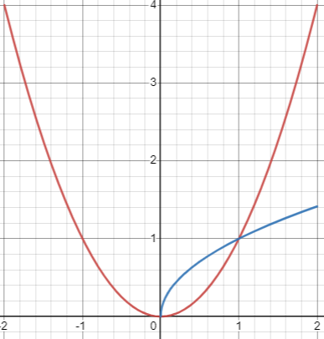
Graphing both $f(x)=x^{2}$ and its inverse $f^{-1}\left(x\right)=x^{1/2}$ on the same set of axes is not difficult at all, and it can be done quite easily. These two functions are inverses of each other, and their relationship is relatively straightforward to visualize. From th graph, it can be seen that $f(x)=x^{2}$ is a parabola that opens upward and is symmetric with respect to the y-axis. ​On the other hand, $f^{-1}\left(x\right)=x^{1/2}$ is the right half of the graph of $y=x^{1/2}$, which is also symmetric with respect to the y-axis. The portion of the graph occupied by the function lies in the first quadrant. Moreover, it can be noted that the point of intersection between these two functions occurs where $y=x$. At the point of intersection, $f\left(x\right)=f^{-1}\left(x\right)$.
Part 2
The function f: R → R with f(x) = x + 1 takes a real number x and adds 1 to it. In f^2 and f^n+1, f^2 represents the composition of the function f with itself, which is f(f(x)) = (x + 1) + 1 = x + 2. On the other hand, f^n+1 represents the composition of the function f with itself n+1 times. It is indeed true that f^2 ◦ f = f ◦ f^2, which can be proved by calculating each side to see if they are equal:
- f^2 ◦ f means applying f^2 to the result of applying f. So, f^2(f(x)) = f^2(x + 1) = (x + 1) + 2 = x + 3.
- f ◦ f^2: This means applying f to the result of applying f^2. So, f(f^2(x)) = f(x + 2) = (x + 2) + 1 = x + 3.
Since f^2 ◦ f and f ◦ f^2 give the same result of x + 3, we can conclude that f^2 ◦ f is equal to f ◦ f^2.
To examine if the set {g: R → R | g ◦ f = f ◦ g} is infinite, we need to consider that the set {g: R → R | g ◦ f = f ◦ g} represents the set of functions g that commute (satisfy the commutative property) with the function f. In other words, g(f(x)) = f(g(x)) for all real numbers x. Considering a function g: R → R such that g(x) = x + c, where c is a constant, we can check if g satisfies the condition g ◦ f = f ◦ g as follows:
g(f(x)): g(f(x)) = g(x + 1) = (x + 1) + c.
f(g(x)): f(g(x)) = f(x + c) = (x + c) + 1 = x + c + 1.
For these two compositions to be equal, we must have (x + 1) + c = x + c + 1, which is true for all real numbers x, regardless of the value of c. Therefore, any function g of the form g(x) = x + c will satisfy the condition g ◦ f = f ◦ g. Since there are infinitely many possible values for the constant c, there are infinitely many functions g that satisfy the condition g ◦ f = f ◦ g. Thus, the set {g: R → R | g ◦ f = f ◦ g} is indeed infinite.

